The Rotating Pendulum in Fractional Sense

Jihad Asad^{1,*}Dumitru Baleanu^{2,3}, Amin Jajarmi⁴, and Noorhan F. AlShaikh Mohammad¹

¹ Palestine Technical University, Faculty of Applied Sciences, Department of Physics, Tulkarm, Palestine

² Lebanese American University, Department of Computer Science and Mathematics, Beirut, Lebanon
³ Institute of Space Sciences, Magurele, Bucharest, Romania
⁴ Department of Electrical Engineering, University of Bojnord, Bojnord, Iran

Abstract: This work presents a fractional-order formulation of a pendulum attached to a rotating support using the principles of analytical mechanics and fractional calculus (see Fig. 1). The classical Lagrangian and Hamiltonian descriptions of the rotating pendulum are first derived from the kinetic and potential energies of the system. Subsequently, the conventional equation of motion is generalized by introducing a fractional derivative operator, leading to a fractional equation of motion that incorporates memory effects and nonlocal dynamics.
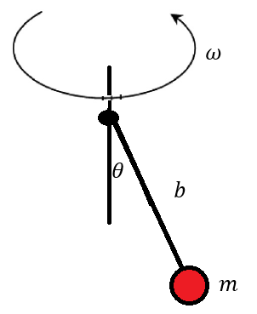

Figure 1: The Rotating Pendulum

The developed model naturally recovers the classical formulation when the fractional order approaches unity. Numerical simulations are performed for different values of the rotational parameter to investigate the influence of rotation on the angular displacement and fractional velocity of the pendulum. The obtained results reveal that the fractional-order parameter significantly modifies the oscillatory behavior, amplitude evolution, and dynamical response of the system. The proposed framework provides a more comprehensive description of rotating pendulum dynamics and may be useful for modeling complex mechanical systems exhibiting hereditary and viscoelastic effects. The findings demonstrate the effectiveness of fractional calculus in extending classical mechanical models and capturing dynamical phenomena that cannot be adequately represented by integer-order formulations.
References
[1] Goldstein H, Poole C, Safko J. Classical Mechanics. 3rd ed. Addison-Wesley; 2002.
[2] Podlubny I. Fractional Differential Equations. Academic Press; 1999.
[3] Baleanu D, Diethelm K, Scalas E, Trujillo JJ. Fractional Calculus: Models and Numerical Methods. World Scientific; 2012.
[4] Jajarmi A, Baleanu D. A new iterative method for the numerical solution of high-order nonlinear fractional boundary value problems. Front Phys. 2020;8:220.

