Short-term Temperature Forecast from Single Weather Station Data in an Urban Environment Using Echo State Networks

Grigorios Giagkoudis¹ , Christos Volos¹ and Ioannis P. Antoniades¹
¹ Laboratory of Nonlinear Systems, Circuits & Complexity (LaNSCom), Department of Physics,
Aristotle University of Thessaloniki, Thessaloniki, Greece,
Corresponding author e-mail: iantoniades@auth.gr

Abstract:
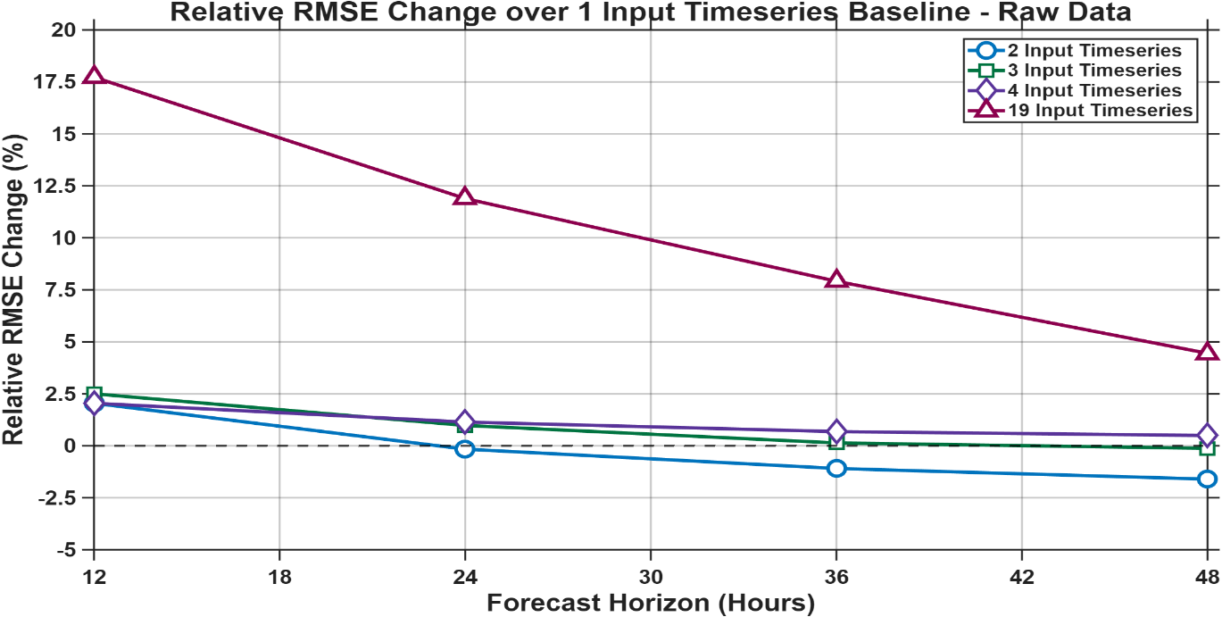
In recent years, different machine learning architectures have proven to be a computationally tractable alternative to conventional methods. Short-term weather prediction is an ongoing challenging problem in computational physics and meteorology, due to the deterministic chaos and highly non-linear nature of atmospheric systems [1]. Moreover, reconstructing complex phase space trajectories in the presence of incomplete observations from local weather stations remains problematic for conventional numerical weather prediction models. For this reason, this research reports a Reservoir Computing framework based on the Echo State Network (ESN) architecture, which represents a computationally efficient class of recurrent neural networks [2]. The framework is optimized through the architecture derived from Multisensory Integration (MSI), a concept stemming from cognitive science [3], in order to investigate meteorological data forecasting using temporally correlated data from a single local sensor, in an urban environment, and possibly supplementary local meteorological data.
Figure 1: RMSE metric temporal evolution – Ascending input timeseries number
The experimental data consisted of multivariate time-series of meteorological variables (temperature, relative humidity, wind speed, and wind direction) that were gathered from a single local weather station, on an urban environment, and formed into structured ESN input using a custom interface developed in MATLAB. Supplementary local meteorological data were also used, from another local urban sensor location. Processing frameworks were applied strictly for regularization, time-alignment and de-noising of data; in particular the filtering techniques employed were the moving average (movmean) smoothing and frequency domain Fourier denoising. Variations in smoothing and Fourier denoising resulted in altering the trajectories over time, which in turn trained the ESN to experience different state-space regimes during its training phase. The target variable was chosen to be hourly temperature time-series, divided into train/validation/test sets in an 80/10/10 manner. The target was designed to examine the preceding 120-hour time window to produce 48-hour ahead localized forecasts.
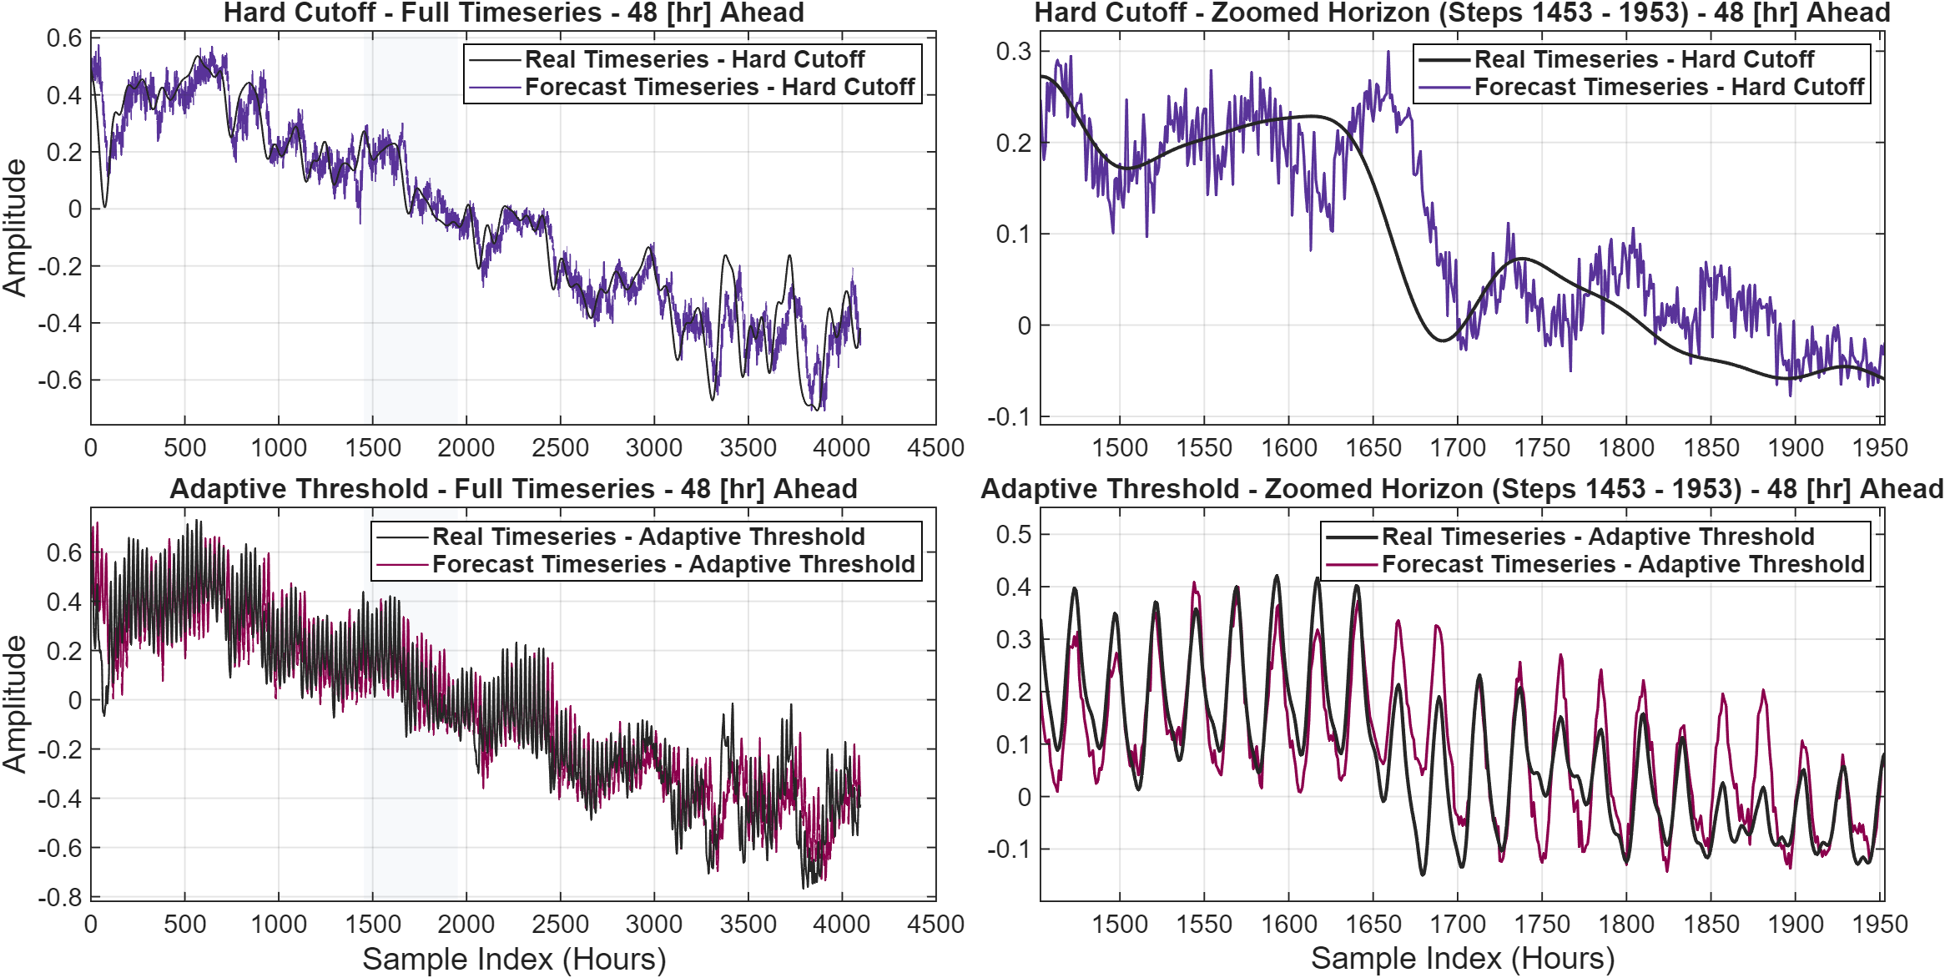
The hyperparameter optimization process focused on optimizing the values of the leaking rate (α) and spectral radius (ρ) within the configuration of a single-layered reservoir that uses a constant range of nodes to stabilize the fading memory mechanism. Later stages focused on tuning of the input scaling weights (θ) and delays parameter (τ), optimizing the amount of past state information processed per time step. Performance and internal reservoir dynamics were monitored by the Root Mean Square Error (RMSE) and its temporal profile, Pearson’s $R^{2}$, a trajectory stability index and extreme events tracking quantified via minimum/maximum F1 score and recall values, with time and amplitude shifts incorporated.
Figure 2: Forecasting results for Fourier denoised input timeseries, different cutoff frequencies
The empirical findings have shown that the MSI-driven ESN framework can successfully capture key chaotic attractor dynamics of the local meteorological data time-series and reduce forecast drift across the 48-hour horizon. Comparative evaluations revealed that configurations integrating a higher number of parallel meteorological time-series consistently yielded superior predictive precision, that lead to lower RMSE values and demonstrated clear architectural synergistic properties. The efficiency of data smoothing and frequency domain Fourier denoising in removing the noisy high frequency signals from deterministic trajectories has also demonstrated significant improvements in $R^{2}$ and RMSE values that meet the performance requirements of real-world applications, indicating that the proposed approach can achieve accurate forecasting while maintaining low computational cost. The best proposed ESN model with smoothed inputs consistently produced RMSE values of 0.046 and $R^{2}$ values of 0.764 (values normalized), while it reduced RMSE by 14% relative to a baseline ESN (with only one raw input timeseries), with a training runtime of only 69 minutes for 10 complete individual simulations (averaging 6.9 minutes per simulation), on a CPU (AMD Ryzen 5 5500U@2.1GHz) Lenovo laptop.
Keywords: Reservoir Computing, Echo State Networks, Recurrent Neural Networks, Chaotic Weather Forecasting, Multisensory Integration, Time-Series Prediction.
References
- [1] Jaideep Pathak, Brian Hunt, Michelle Girvan, Zhixin Lu, and Edward Ott. Model-free prediction of large spatiotemporally chaotic systems from data: A reservoir computing approach. Phys. Rev. Lett., 120:024102, Jan 2018.
- [2] Mantas Lukoševičius and Herbert Jaeger. Reservoir computing approaches to recurrent neural network training. Computer Science Review, 3(3):127-149, 2009.
- [3] I. Choi, I. Demir, S. Oh, and S. H. Lee. Multisensory integration in the mammalian brain: diversity and flexibility in health and disease. Philos. Trans. R. Soc. Lond. B Biol. Sci., 378(1886):20220338, 2023.

