Saltatory propagation in lattices of excitable micropillar lasers

S. Barbay¹, L. Soun¹, R. Braive¹, I. Sagnes¹, G. Beaudoin¹, R. Gajardo², L. Toro², M. G. Clerc², K. Alfaro-Bittner³,
¹Université Paris-Saclay, CNRS, Centre de Nanosciences et de Nanotechnologies, Palaiseau, France
²Universidad de Chile, Departamento de Física and Millennium Institute for Research in Optics, Santiago, Chile
³Universidad Rey Juan Carlos, Madrid, Spain
e-mail: sylvain.barbay@c2n.upsaclay.fr

Abstract: Excitable micropillar lasers show good promise for neuromorphic photonic computing applications. When assembled in lattices, they sustain the stable propagation of saltatory pulses whose collision properties lead to emerging on-chip neuromorphic computing primitives. We present numerical and experimental results on this system, and discuss prospects.

Keywords: neuromorphic photonics, excitability, coupled photonic nodes, semiconductor lasers, nonlinear lattices
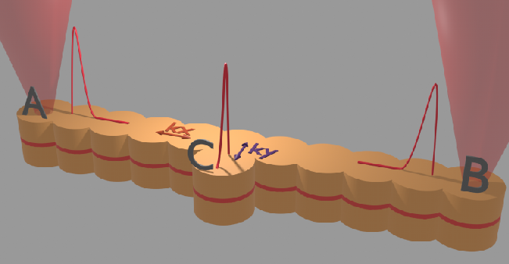Fig. 1: Schematic representation of a lattice of excitable micropillar lasers with inputs A, B and output C. After [3].
Excitable micropillar lasers have been shown to behave analogously to biological neurons but with much faster timescales (nanoseconds vs milliseconds) [1] and show good promise for photonic brain-inspired computing applications [2]. These systems are operated below laser threshold, and when subject to a perturbation they can either fire an optical spike (100ps pulse) if an excitation threshold is reached or remain in their quiet stable state, in close analogy with neuronal response but in the optical domain. The excitable micropillar laser consists of a semiconductor microcavity structure with a typical diameter of 5µms (see Fig. 1) with two high-reflectivity multilayer mirrors enclosing an active zone comprising a gain and a saturable absorber section made of quantum wells. The micropillar lasers are pumped optically around 800nm and emit around 980nm. The micropillars can be arranged in a lattice structure (Fig. 1) giving rise to a lattice of coupled ultrafast excitable cells.

We show numerically and through preliminary experimental results, that when the lattice is driven in the excitable regime, and if it is perturbed locally (e.g. in A or B), it can sustain the stable propagation of saltatory soliton-like structures [1]. By injecting perturbations at both inputs, and reading the output in C, the lattice acts as a temporal logic gate [3] and can emulate the XOR function by carefully engineering the local micropillar couplings. Apart from the potential applications, this demonstrates that even a simple photonic structure can emulate a non-separable gate. This opens interesting prospects for on-chip neuromorphic circuits, in particular leveraging on the modulation of the coupling constants for topological lattices with novel properties.

Acknowledgement: This work has been partially supported by the French Renatech Network of cleanroom facilities.

References
[1] V. A. Pammi, K. Alfaro-Bittner, M. G. Clerc and S. Barbay, IEEE J. Sel. Top. Quantum Electron., 26, 1500307 (2020).
[2] D. Brunner, B. J. Shastri, M. A. Al Qadasi, H. Ballani, S. Barbay et al., arXiv:2501.07917v2 (2025).
[3] L. Soun, K. Alfaro-Bittner, M. G. Clerc, and S. Barbay, Chaos Solitons & Fractals, 164, 112537 (2022).

