Transition Waves in Nonlinear Mechanical Metamaterial Chains with Neighbor-Dependent Potential Bistability

E. Duval¹, G. Risso², A. Zhang^{2,3} , V. Tournat^{1,2}, K. Bertoldi²
¹Laboratoire d’Acoustique de l’Université du Mans (LAUM), UMR 6613,
Institut d’Acoustique - Graduate School (IA-GS), CNRS, Le Mans Université, France
²School of Engineering and Applied Sciences, Harvard University, Cambridge, Massachusetts 02138, USA
³Department of Mechanical & Industrial Engineering,
University of Toronto, Toronto, ON M5S 3G8, Canada
e-mail: vtournat@univ-lemans.fr

Abstract: Transition waves in mechanical metamaterial chains are propagating domain walls separating regions of the lattice with unit cells in distinct stable states. In most of the reported results in the literature on this topic, metamaterial chains are fabricated with intrinsically bistable units, e.g. a von Mises truss, a buckled beam, that are then elastically coupled to their left and right neighbors [1-4]. Here, inspired by the strategy described in [5] for statics, we propose a different architecture where the units are either monostable or bistable, depending on the state of their neighboring units. As illustrated in the snapshots of the experiment shown in Fig. 1, a metamaterial chain made of these units can support sharp transition front propagation.
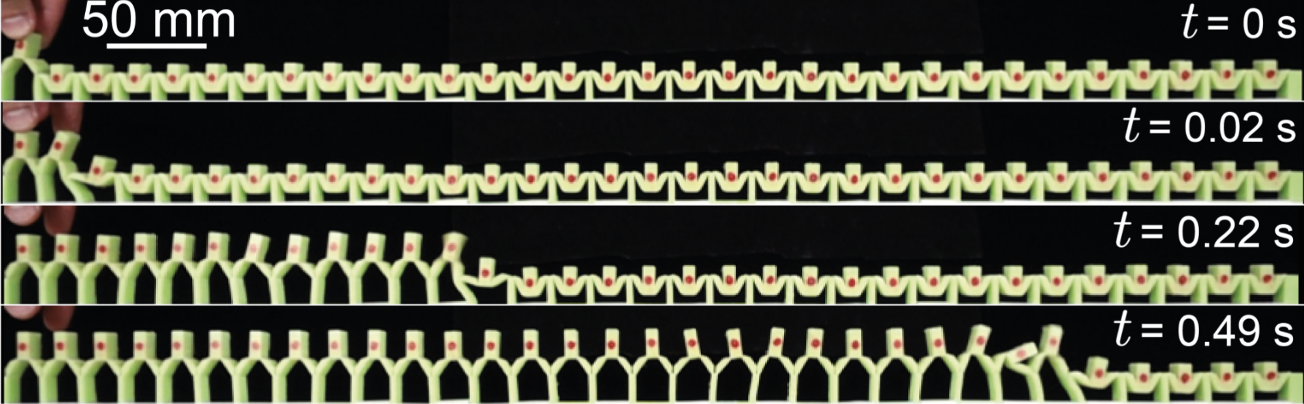
Fig. 1: Snapshots of the transition wave movie showing the propagation after triggering from the left end of the chain.

We analyze the transition wave propagation characteristics via experiments on several metamaterial chains. Results are quantitatively compared to numerical simulations based on a lumped parameter model, which is then used to explore the design parameter space. From forward simulations in the time domain, we construct a simulation-based bifurcation diagram showing regions with no propagation (individual units are bistable whatever the state of the neighboring units), partial propagation or robust propagation leading to the full reconfiguration of the sample. The transition wave fronts are highly discrete, can propagate in both directions, and exist only for transition from the higher energy state to the lower one of each unit. Additionally, we propose and explore several ways to tune the wave front propagation speed.
In the prospects of this presentation, we will discuss extensions to two-dimensional systems [6] and discuss possible functionalities that can be envisioned with this specific metamaterial chain [7,8].

Keywords: Transition wave, nonlinear flexible mechanical metamaterial, multistable mechanical lattice
Acknowledgement: G.R. acknowledges support from the Swiss National Science Foundation under Grant No. P500PT-217901. E.D. thanks the Institut d’Acoustique - Graduate School at Le Mans University for financial support (IA-GS,ref. 17-EURE-0014). V.T. acknowledges support from project ExFLEM ANR-21-CE30-0003-01, and CNRS IRP DynaMetaFlex. K.B. acknowledges support from the Simons Collaboration on Extreme Wave Phenomena Based on Symmetries

References
[1] N. Nadkarni, C. Daraio, and D. M. Kochmann, Dynamics of periodic mechanical structures containing bistable elastic elements: From elastic to solitary wave propagation, Phys. Rev. E 90, 023204 (2014).
[2] N. Nadkarni, A. F. Arrieta, C. Chong, D. M. Kochmann, and C. Daraio, Unidirectional Transition Waves in Bistable Lattices, Phys. Rev. Lett. 116, 244501 (2016).
[3] J. R. Raney, N. Nadkarni, C. Daraio, D. M. Kochmann, J. A. Lewis, and K. Bertoldi, Stable propagation of mechanical signals in soft media using stored elastic energy, Proc. Natl. Acad. Sci. 113, 9722 (2016).
[4] M. Hwang and A. F. Arrieta, Input-Independent Energy Harvesting in Bistable Lattices from Transition Waves, Scientific Reports 8, 22003-7 (2018).
[5] G. Risso, L. Pesaresi, A. Meeussen, and K. Bertoldi, Conditional stability in metamaterials: Experiments, modeling, and 3D design, Extreme Mechanics Letters 79, 102393 (2025).
[6] L. Jin, et al., Guided transition waves in multistable mechanical metamaterials, Proc. Natl. Acad. Sci. 201913228 (2020).
[7] H. Yasuda, H. Shu, W. Jiao, V. Tournat, and J. R. Raney, Nucleation of transition waves via collisions of elastic vector solitons, Appl. Phys. Lett. 123, 051701 (2023).
[8] D. Jin, S. Ferracin, V. Tournat, S. Patel, P. Purohit, J.R. Raney, Transition waves in a beam coupled to a foundation of symmetric bistable elements, Phys. Rev. Applied 25, 014064 (2026).

