Nonlinear Wave Propagation in a One-Dimensional Mass-in-Mass Chain

Audrey A. Watkins¹, Giovanni Bordiga¹, Vincent Tournat^{1,2}, Katia Bertoldi¹
¹Harvard University, School of Engineering and Applied Science, Cambridge, MA, USA
²Laboratoire d’Acoustique de l’Université du Mans (LAUM), UMR 6613, Institut d’Acoustique – Graduate School (IA-GS), CNRS, Le Mans Université, France
e-mail: audreywatkins@g.harvard.edu

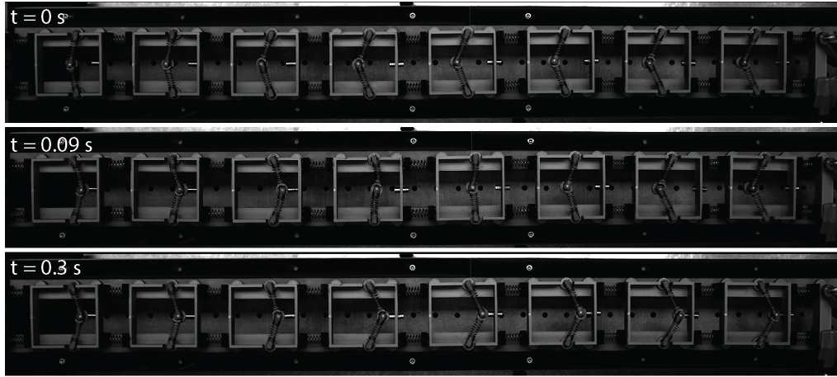
Abstract: The study of nonlinear wave propagation in mechanical metamaterials composed of arrays of bistable elements has garnered increasing interest. Many existing platforms have shown that by elastically coupling adjacent bistable elements, interesting phenomena such as transition waves can be supported in the system [1-3]. Most of these existing platforms exhibit a domino-like effect, where a localized perturbation causes one bistable element to switch from one stable state to another, and that switch triggers neighboring coupled bistable elements to follow, until all elements have transitioned to their lower energy states. In this study, we explore a new type of coupling between bistable elements through their inertia, such that the bistable elements are statically decoupled, yet dynamically switchable through an inertial coupling. While phenomena such as transition waves are still observable, the absence of direct elastic coupling between neighboring elements permits control of the transition wavefront as well as selective transitioning of bistable elements at arbitrary locations in the metamaterial [4]. We show that by carefully designing the bistable energy landscapes, we can program interesting functionalities into the metamaterial such as sensing of mechanical load history and wave filtration. Finally, we propose a strategy to dynamically read the state of the metamaterial using low-amplitude waves.
Fig. 1: Propagation of a transition wave through the one-dimensional mass-in-mass metamaterial with N=8 unit cells

Keywords: transition waves, metamaterials, wave control

Acknowledgement: This work was supported by the Simons Collaboration on Extreme Wave Phenomena Based on Symmetries, by the National Science Foundation (NSF) under award no. 2118201, by CNRS via IRP DynaMetaFlex and by the Chateaubriand Fellowship of the Office for Science & Technology of the Embassy of France in the United States.

References
[1] J. R. Raney, N. Nadkarni, C. Daraio, D. M. Kochmann, J. A. Lewis, and K. Bertoldi, Stable propagation of mechanical signals in soft media using stored elastic energy, Proc. Natl. Acad. Sci. 113, 9722 (2016).
[2] N. Nadkarni, A. F. Arrieta, C. Chong, D. M. Kochmann, and C. Daraio, Unidirectional Transition Waves in Bistable Lattices, Phys. Rev. Lett. 116, 244501 (2016).
[3] L. Jin, et al., Guided transition waves in multistable mechanical metamaterials, Proc. Natl. Acad. Sci. 201913228 (2020).
[4] Watkins, A. A., Bordiga, G., Mu, M., Tournat, V., & Bertoldi, K., Arbitrary mechanical memory encoding via nonlinear waves in bistable metamaterials. arXiv preprint arXiv:2508.20321 (2025).

