On topological entropy of a memristor-based circuit

Łukasz Derwisz¹, Zbigniew Galias¹
¹AGH University of Kraków, Department of Electrical Engineering, Kraków, Poland
e-mail: galias@agh.edu.pl

Abstract: Memristive circuits form an important class of nonlinear dynamical systems, since memory effects combined with a strong nonlinearity may lead to rich oscillatory behavior. Locally active memristors (LAM) are particularly suitable for compact chaotic oscillators, since their negative differential resistance (NDR) regions can sustain oscillations and contribute to the onset of complex dynamics [1-2]. The circuit considered in this work is an inductor-free third-order oscillator composed of an S-type current-controlled and an N-type voltage-controlled locally active memristors, a capacitor, a resistor, and a DC voltage source [1]. The circuit diagram is shown in Fig. 1.

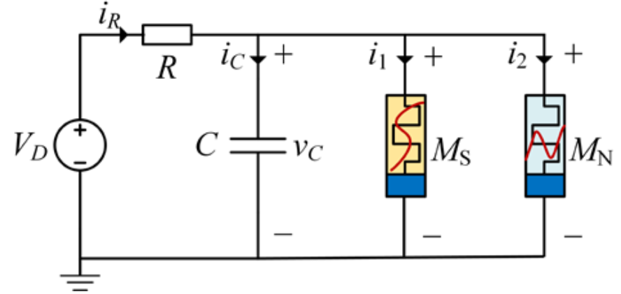

Fig. 1. Schematic diagram of the double locally active memristor-based inductor-free chaotic circuit [1].

The dynamics of the circuit is defined by the following set of differential equations:
$${\overset{˙}{x}}_{1}\text{=}α_{1}\left(α_{0}\text{+}x_{1}\text{+}β_{1}{v_{C}}/{\left(d_{2}x_{1}^{2}\text{+}d_{0}\right)}\right),$$
$$C{\overset{˙}{v}}_{C}\text{=}\left({\left(V_{D}−v_{C}\right)}/R−G_{0}v_{C}x_{2}^{2}−{v_{C}}/{\left(d_{2}x_{1}^{2}\text{+}d_{0}\right)}\right),$$ | (1)
$${\overset{˙}{x}}_{2}\text{=}γ\left(−k_{1}x_{2}\text{+}k_{2}v_{C}\right).$$
The system is considered with parameters $d_{2}\text{=}100,$ $d_{0}\text{=}300,$ $α_{0}\text{=}−9,$ $α_{1}\text{=}−{10}^{4},$ $β_{1}\text{=}2500,$ $G_{0}\text{=}{10}^{−3},$ $k_{1}\text{=}2.5,$ $k_{2}\text{=}1.25,$ $γ\text{=}500,$ $V_{D}\text{=}11.5,$ and $C\text{=}7×{10}^{−8}.$ The parameter $R$ is treated as a bifurcation parameter.
The goal of this research is to estimate the topological entropy of the system (1) by finding short periodic orbits embedded in observed attractors. Obtaining accurate estimates of topological entropy, which measures the complexity of the system, is often a challenging numerical and theoretical problem.
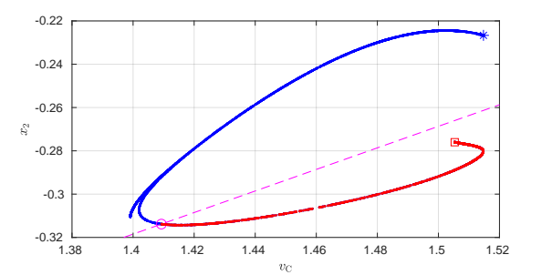
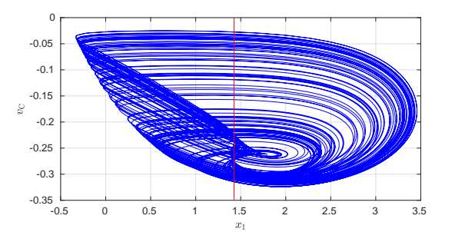

Fig. 2. (a) a trajectory with the length $T\text{=}0.1$ of the continuous-time system, (b) a trajectory of $P$ composed of $N\text{=}5000$ points.

Fig. 2(a) shows a trajectory of the system (1) for $R\text{=}3191.$ The plane $x_{1}\text{=}1.425$ is used to define the return map $P.$ A trajectory of $P$ is plotted in Fig. 2(b). The method developed in [3] is used to find periodic orbits of $P.$ The method is based on a symbolic representation of trajectories satisfying the condition that different periodic orbits correspond to different symbol sequences. In this method, for each admissible periodic sequence a candidate for a periodic orbit is constructed and the Newton method is used to confirm the existence of a periodic orbit with the given symbol sequence. To define the symbolic representation of trajectories the point in a long trajectory with the largest value of $v_{C}$ located in the upper part of the plot is found. This point, its image and preimage are plotted in Fig. 2(b) using the star, the circle, and the square symbols, respectively. A straight line passing through the preimage and not intersecting the trajectory plot (dashed line in Fig. 2(b)) is used to define symbolic representation of points belonging to the trajectory.
The method is applied to find periodic orbits with periods $p≤25$ and 18643 such periodic orbits are found. The proposed method finds significantly more periodic orbits than the number of periodic orbits detected by the method of close returns [4], which searches for periodic orbits by trajectory monitoring. It failed to detect all 2094 periodic orbits with periods $p≤20$ found by the proposed method in spite of very long computations. The number of periodic orbits found is used to obtain approximations of the topological entropy $H$of $P$ using the formula $H\text{=}\lim_{p→∞}{H_{p}}\text{=}\lim_{p→∞}{\frac{1}{p}}logQ_{p},$ where $Q_{p}$ is the number of fixed points of the $p$th iterate of $P.$ Similar calculations carried out for $R\text{=}3196$ and $R\text{=}3201$ yield 13964 and 6919 periodic orbits, respectively. Estimates of the topological entropy for the cases considered are plotted in Fig. 3(a). Fast convergence is observed. Estimates converge to $H≈0.481,$ $H≈0.468,$ and $H≈0.438$ for $R\text{=}3191,$ $R\text{=}3196,$ and $R\text{=}3201,$ respectively. Fig. 3(b) shows positions of considered parameter values in the bifurcation diagram of $P.$
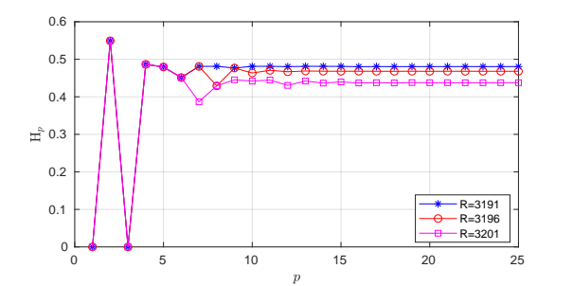
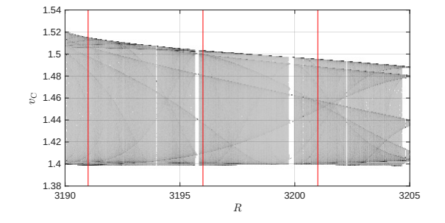
Fig. 3. Estimates of the topological entropy based on the number of periodic orbits with period $p.$

Keywords: memristor, chaotic oscillator, unstable periodic orbit, return map, topological entropy.

Acknowledgement: This work was supported by the National Science Centre, Poland under Grant 2024/53/B/ST7/03841 and by the Ministry of Science and Higher Education (Poland) under the grant for scientific activity.

References
[1] Q. Geng, Y. Liang, Z. Lu, H. H. -C. Iu and G. Wang, ”Double locally active memristor-based inductor-free chaotic circuit,” IEEE International Symposium on Circuits and Systems (ISCAS), 19-22 May 2024, Singapore, Pages 1-5 (2024).
[2] L. O. Chua, "Memristor-the missing circuit element," IEEE Trans. Circuit Theory, 18, Pages 507-519 (1971).
[3] Z. Galias, “A fast method to find periodic orbits in chaotic attractors with applications to the Rössler system”, IEEE Trans. Circuits Syst. II, 70(9), Pages 3659-3663 (2023).
[4] D. Lathrop and E. Kostelich, “Characterization of an experimental strange attractor by periodic orbits,” Phys. Rev. A., 40(7), Pages 4028-4031 (1989).

