A Hybrid Fractional-Order and Intelligent PD Control Scheme for Enhanced Performance of Serial Robot Manipulators

Mihailo P. Lazarević¹, Nikola LJ. Živković², Stjepko Pišl¹
¹Faculty of Mechanical Engineering, Department of Mechanics, Belgrade, Serbia
²R&D Institute Lola Ltd., Department of Robotics, Belgrade, Serbia
e-mail: mlazarevic@mas.bg.ac.rs

Abstract: Trajectory tracking performance is a key determinant of a control system's quality in applications involving serial robot manipulators, especially for tasks that demand high precision, such as 3D printing, welding, and surgical and rehabilitative robotics [1,2]. This research proposes a hybrid controller for increasing the performance of serial robot manipulators. The proposed control scheme consists of an intelligent PD controller (iPD), [3] and a fractional-order controller (FOC),[4] operating in parallel, as illustrated in Fig 1. The iPD controller is based on the ultra-local model representation of the system dynamics, compensating for all nonlinearities, uncertainties, and external disturbances [3]. The FOC is a linear controller characterized by the following transfer function form:
$FOC=K_{f}\frac{s^{β}}{s^{α}+1},$ (1)
where $K_{f}$ is gain, $β$ and $α$ are fractional order values for numerator and denominator of the transfer function, respectively. All three parameters of the FOC, $K_{f}$, $α$ and $β$, with the addition of proportional $K_{p}$and derivative gains $K_{d}$ of the iPD controller are tuned using the PSO algorithm. The simulation results demonstrate that adding the FOC enhances control system performance by reducing the error signal, as shown in Fig. 2.
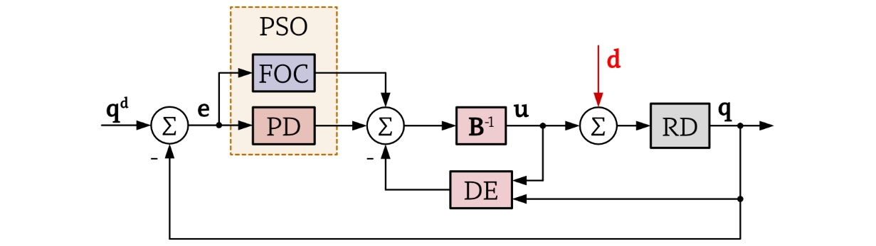
Fig. 1. Control scheme diagram of proposed hybrid FOC-iPD. RD block is Robot Dynamics, DE is the Dynamics Estimation part of the iPD, and FOC is Fractional-order Controller as described with (1).
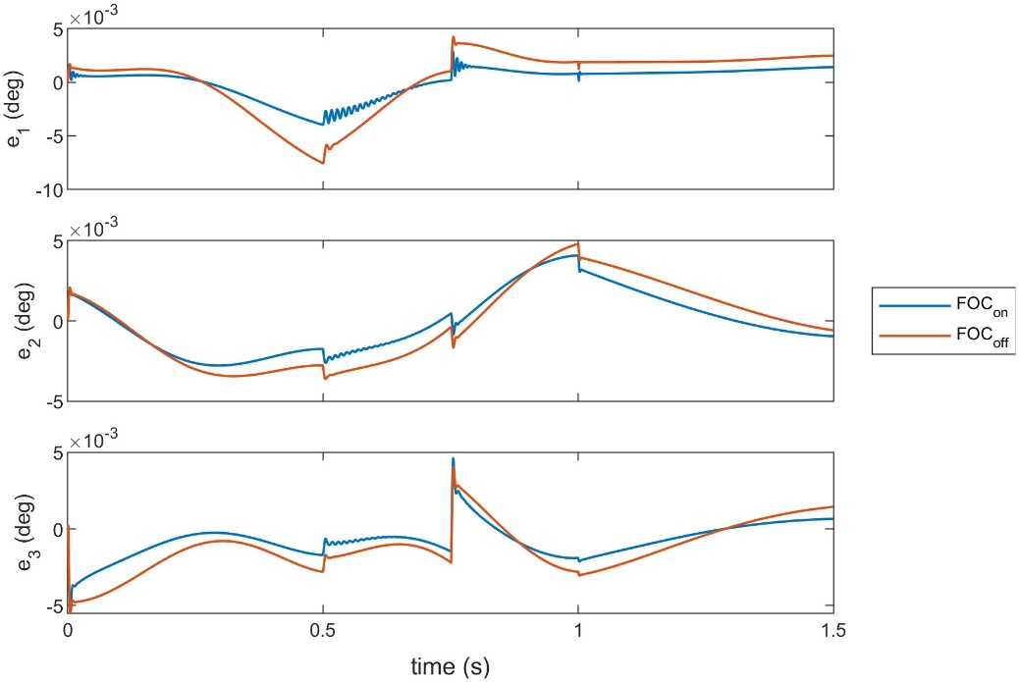
Fig. 2. Joint position errors comparison between default iPD and hybrid FOC-iPD control schemes. FOC_{on} and FOC_{off} labels denote whether FOC controller is active or not.
Keywords: Fractional-order controller, intelligent PID, ultra-local model, serial robot manipulator.

Acknowledgement: This research has been supported by the research grants of the Serbian Ministry of Science, Technological Development, and Innovations, Grant No. 451-03-34/2026-03/200105 from 05.02.2026. and Grant No. 451-03-33/2026-03/200066.

References
[1] E. Barnett, and C. Gosselin, “Large-scale 3D printing with a cable-suspended robot.” Additive Manufacturing, 7, 27-44 (2015).
[2] A. Bertelsen, J. Melo, E. Sánchez, and D. Borro, “A review of surgical robots for spinal interventions.” Int J Med Robotics Comput Assist Surg, 9, 407-422 (2013).
[3] M. Fliess, and C. Join, “Model-free control.” International Journal of Control, 86, 2228-2252 (2013).
[4] P. Mandić, P. Lino, G.Maione, M.Lazarević, and T.Šekara, “Design of Fractional-Order Lag Network and Fractional-Order PI Controller for a Robotic Manipulator.” IFAC PapersOnLine 53-2, 3669-3674 (2020).

